CivicConnect — Project Screenshots
Civic Grievance Management Platform | Medicaps University, B.Tech CSE
- Home Page
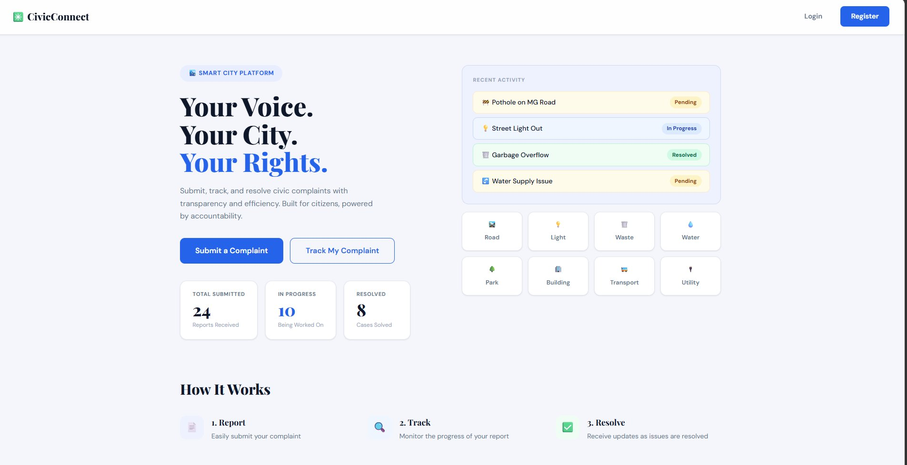

The public landing page of CivicConnect. It displays the platform tagline "Your Voice. Your City. Your Rights." with two main call-to-action buttons — Submit a Complaint and Track My Complaint. The right side shows a live feed of recent complaint activity with real-time statuses (Pending, In Progress, Resolved) and category shortcuts for Road, Light, Waste, Water, Park, Building, Transport, and Utility. A stats bar shows total reports received, complaints in progress, and cases resolved platform-wide.
2. Login Page
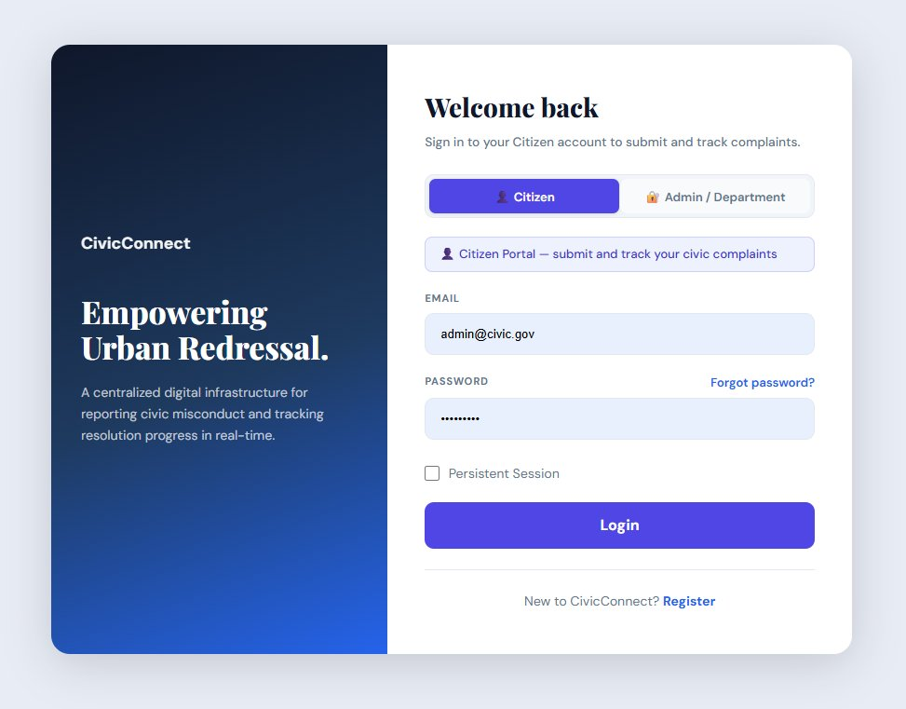

The login screen features a dark navy branding panel on the left with the tagline "Empowering Urban Redressal" and a clean white form panel on the right. Users can switch between Citizen and Admin/Department login using the tab toggle at the top. The form accepts email and password with a Persistent Session option and a Forgot Password link.

- Register Page
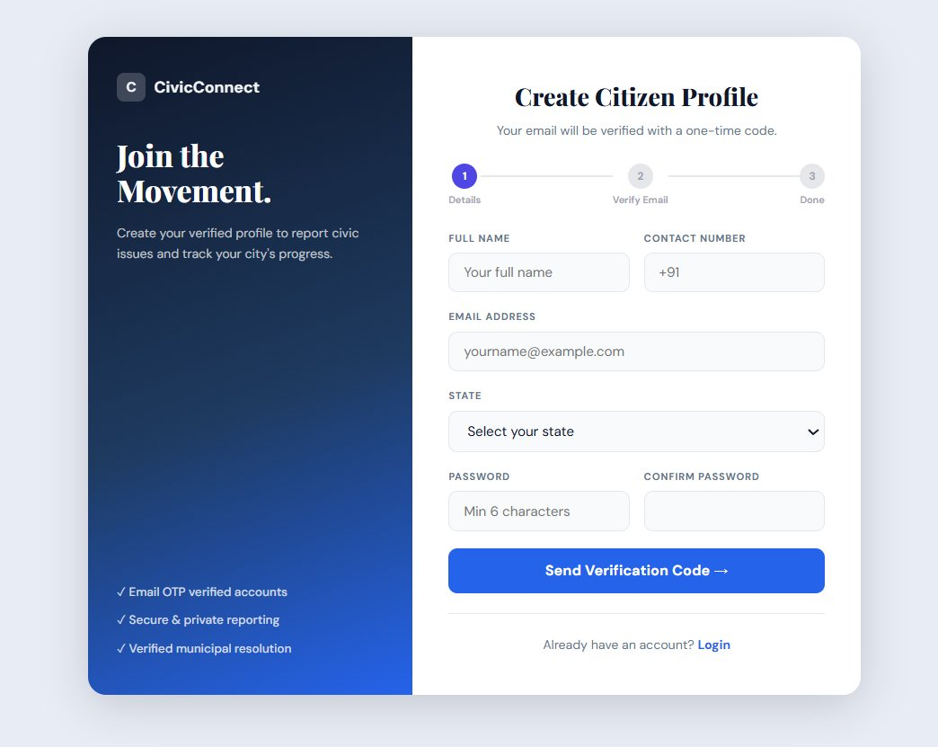

The citizen registration page titled "Create Citizen Profile." It follows a guided 3-step flow: Step 1 collects full name, contact number (+91), email address, state selection, and password. After submitting, a one-time verification code is sent to the email. The left panel highlights three key trust signals — Email OTP verified accounts, Secure & private reporting, and Verified municipal resolution.

4. Citizen Dashboard
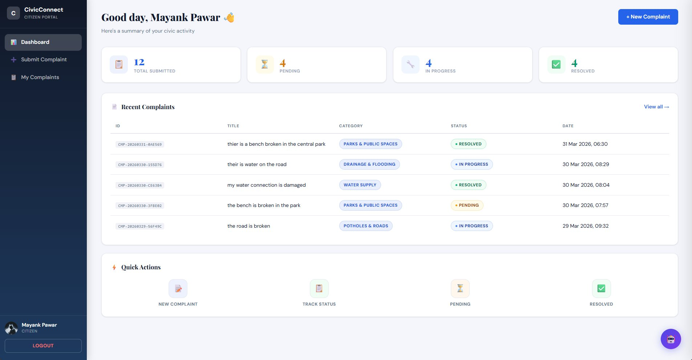
The personal dashboard for a logged-in citizen (Mayank Pawar). Four summary cards at the top display Total Submitted (12), Pending (4), In Progress (4), and Resolved (4). Below is a Recent Complaints table listing complaint IDs, titles, categories with color-coded badges, status tags, and submission dates. Quick Action shortcuts at the bottom allow fast access to New Complaint, Track Status, Pending, and Resolved views.

5. Submit Complaint (with Interactive Map)
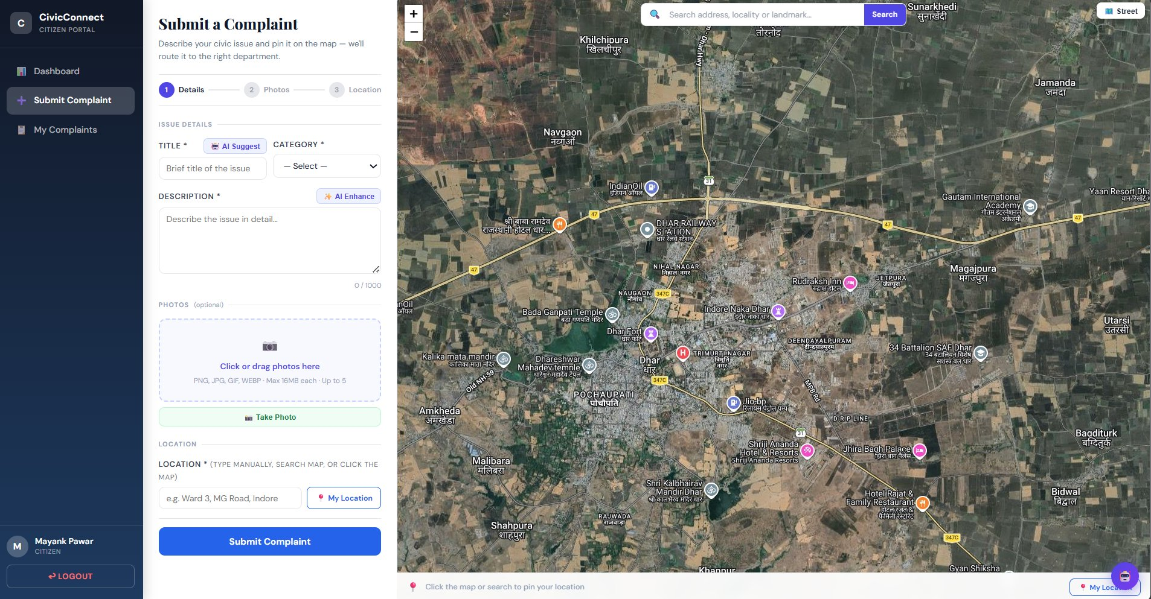

The complaint submission page is split into two panels. The left panel contains the 3-step form — step 1 has the title field with an AI Suggest button, a category dropdown, and a description field with an AI Enhance button. A photo upload area supports PNG, JPG, GIF, and WEBP files up to 16MB each. The right panel shows a full interactive satellite map (Leaflet.js) where citizens can click to drop a pin at the exact issue location, search by address, or use the My Location button to auto-detect GPS coordinates.

6. My Complaints & Complaint Detail View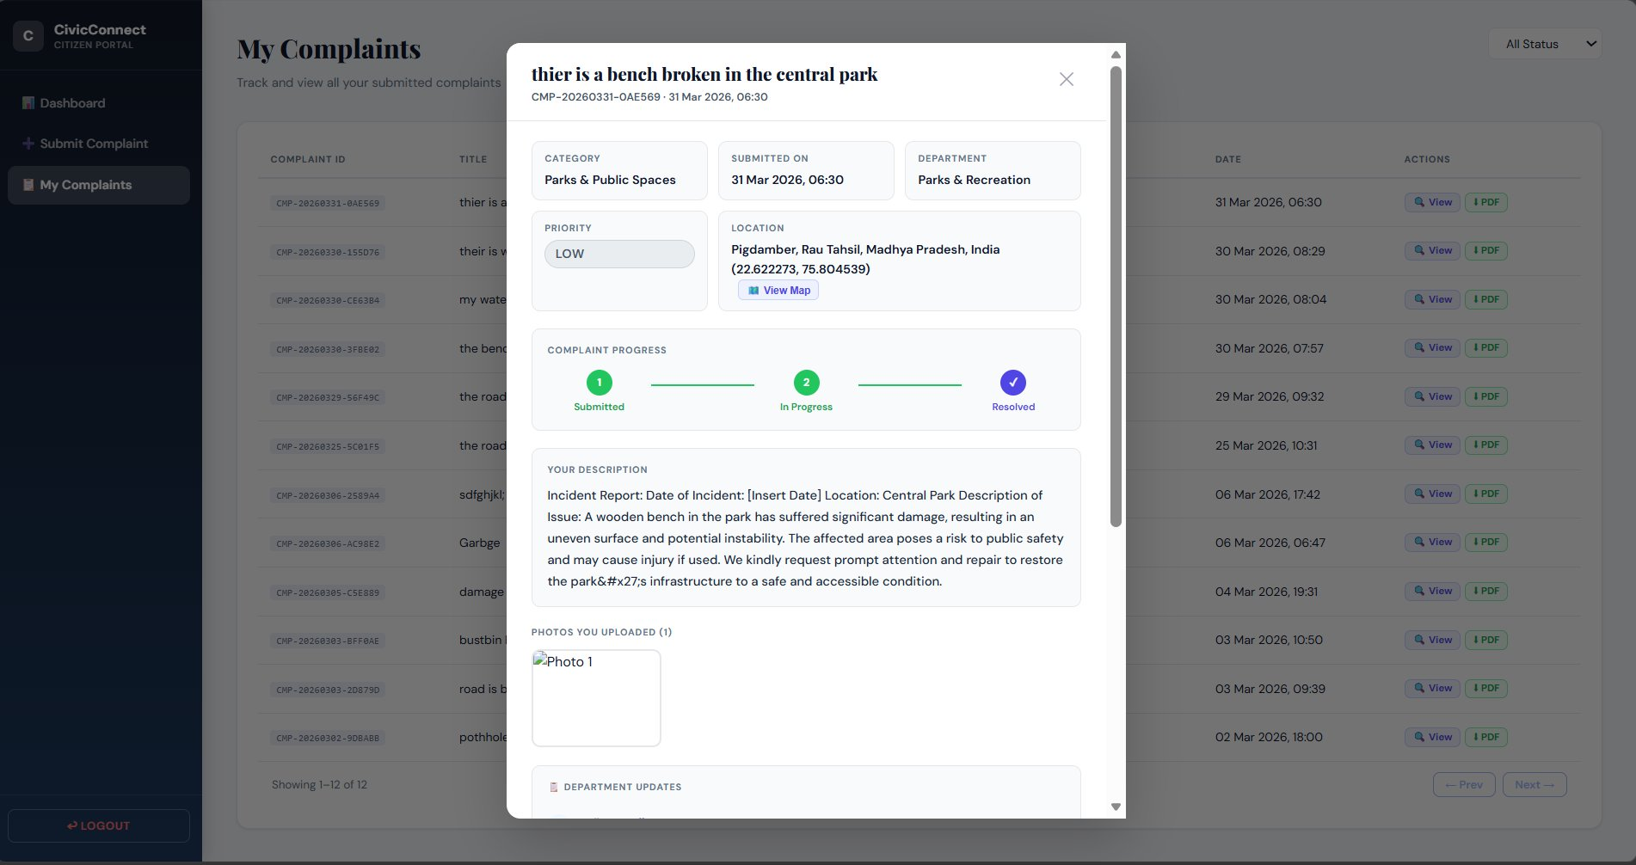

The My Complaints page lists all submitted complaints in a table with complaint IDs, titles, dates, and action buttons (View, PDF). A modal popup is open showing the full detail view of a selected complaint — including the complaint ID (CMP-20260331-0AE569), category (Parks & Public Spaces), assigned department (Parks & Recreation), priority (Low), submission date, GPS coordinates with a View Map link, a 3-step visual progress tracker showing the complaint is Resolved, the full description text, and a photo uploaded by the citizen.

7. Admin — Departments Page
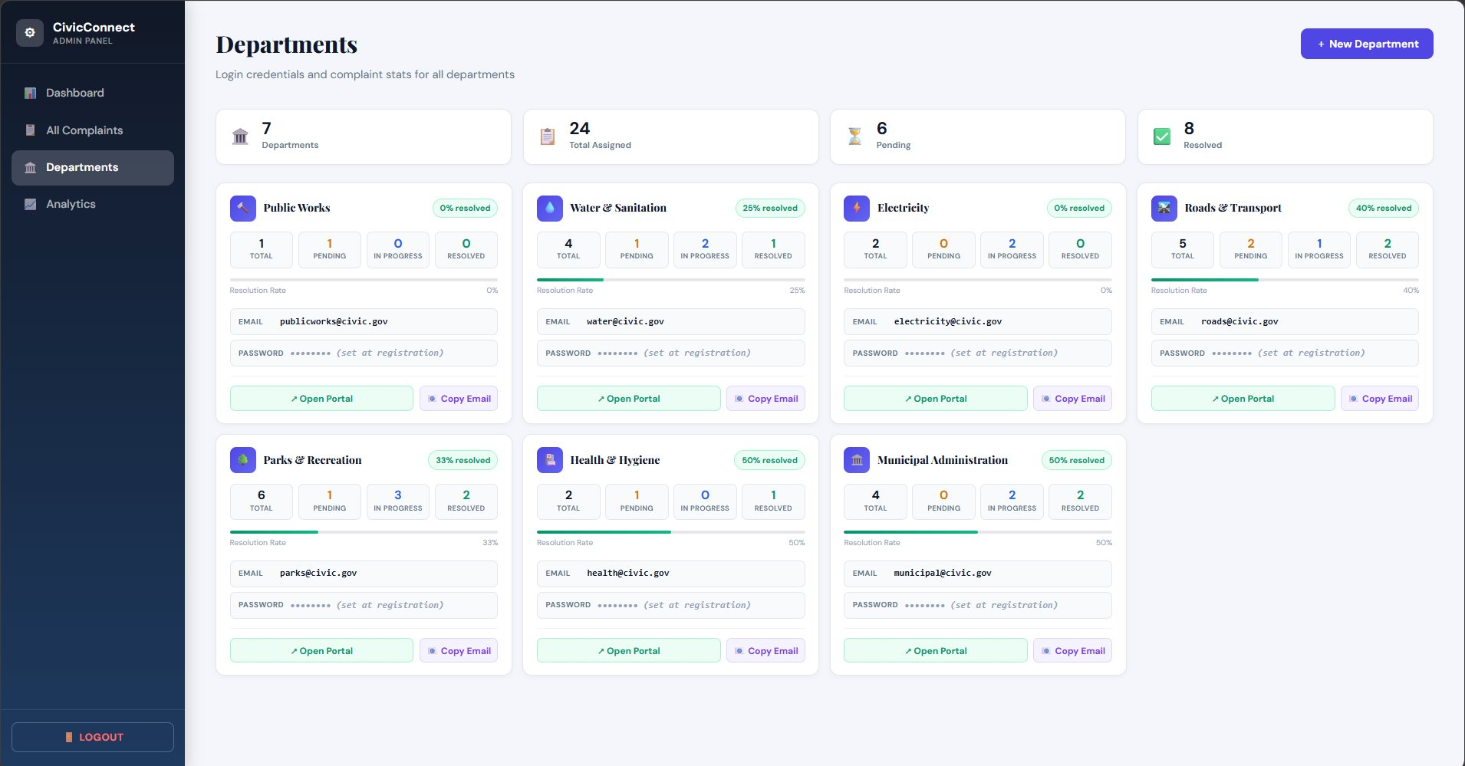

The admin departments management page showing all 7 government departments as individual cards: Public Works, Water & Sanitation, Electricity, Roads & Transport, Parks & Recreation, Health & Hygiene, and Municipal Administration. Each card displays total complaints, pending count, in progress count, resolved count, a visual resolution rate progress bar, and the department login email. Summary stats at the top show 7 departments, 24 total assigned complaints, 6 pending, and 8 resolved. A New Department button is available in the top right.

8. Admin — Analytics Dashboard
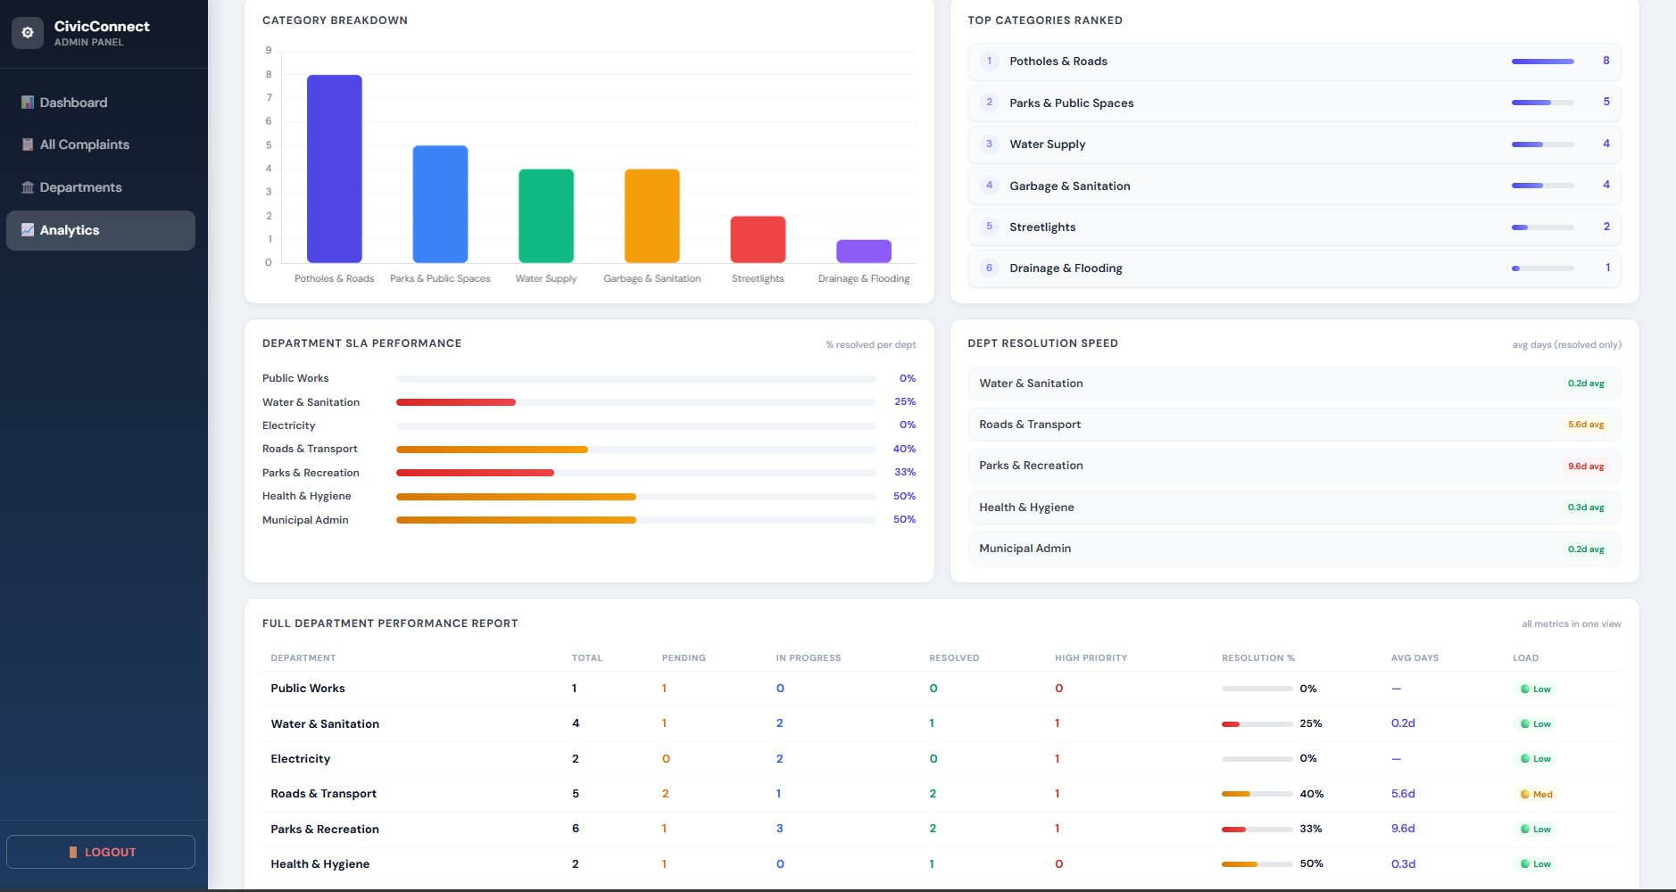
The admin analytics page provides a comprehensive performance overview. The top section has a Category Breakdown bar chart showing complaint volume by category — Potholes & Roads leads with 8 complaints, followed by Parks & Public Spaces (5), Water Supply (4), and Garbage & Sanitation (4). The Top Categories Ranked list on the right shows these rankings with progress bars. The middle section shows Department SLA Performance with horizontal bars indicating resolution percentages per department, and a Department Resolution Speed table showing average days to resolve. The bottom section is a Full Department Performance Report table with columns for Total, Pending, In Progress, Resolved, High Priority, Resolution %, Average Days, and Load rating for every department.

